CITY OF DAVIS
2020-2021 HOME INVESTMENT PARTNERSHIPS PROGRAM APPLICATION

PART ONE:

Organization Name: ___________________________________________________

Name: ___________________________ Title: ______________________ Phone: _____________________

Mailing Address: __________________________________________________________________________

Email Address: ____________________________________________________________________________

PART TWO:

Proposed Project Location: __________________________________________________________________

Total Proposal Request: $______________________ Minimum Request: $ _____________________

Is the applicant claiming status as a Non-Profit Community Housing Development Organization (CHDO)? (Applicants will be required to provide qualifying documentation)

______ Yes _____ No

HOME Eligible Activities Category: ________________________________
(See List A)

Low Income Benefit: ________________________________
(See List B)

City Council Identified Critical Needs: (See List C)

1) _______________________
2) _______________________
3) _______________________
Beneficiary Information:
_ Total number of beneficiaries in proposed project
_ Number of beneficiaries in proposed project to be served with HOME funds
_ Percentage of the HOME beneficiaries with low income
_ Cost ($) per HOME beneficiary (HOME Request/HOME Beneficiaries)

PART THREE: Scope of Proposal

a. Need/Target Group (Describe the need for the activity and the group being served)
b. Project Description/Benefit (Activity Summary: Describe the activities of the proposed budget and benefit)

c. Outreach (Describe the outreach your organization will provide for the CDBG-funded project, as well as provide a list of the languages currently included in your organizational outreach)

d. Organizational Capacity (Summarize your organizational capacity for the proposed project)

e. Partnerships and Other Resources (List other agencies you collaborate with and indicate whether or not your proposed project is duplicative of other projects operated by local public or non-profit organizations)

PERFORMANCE MEASUREMENTS AND SCHEDULE

ACTIVITY  (What the program does to fulfill its mission) | INDICATOR  (The direct products of program activities)  SERVICE #s | OUTCOME  (Benefits that result from the program) | COMPLETION DATE  (When the specific task is completed)

CAPITAL PROJECT BUDGET SUMMARY*
* Please use Capital Budget Summary Excel form available on the City of Davis website and revise budget items as needed

CITY OF DAVIS
HOME INVESTMENT PARTNERSHIPS PROGRAM
CAPITAL BUDGET SUMMARY*
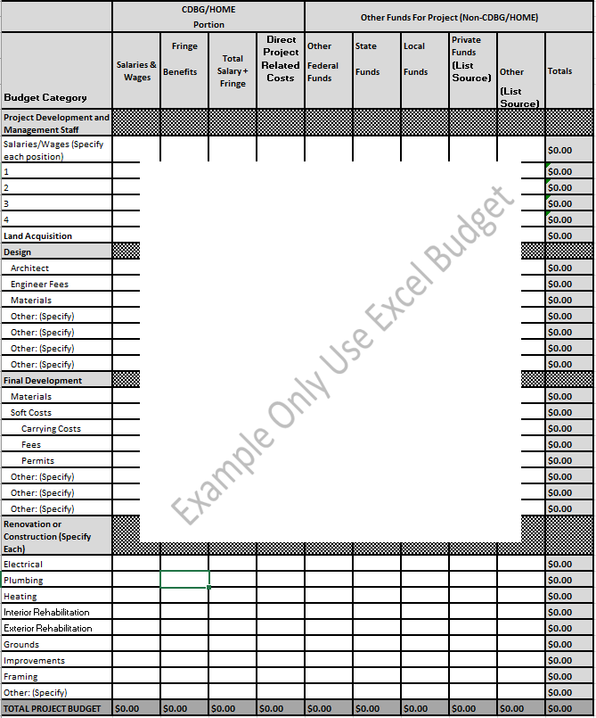

REQUIREMENTS: All applicants are requested to submit a copy of their organizations operating budget and documents requested by the city to complete the required HOME Underwriting and Subsidy Layering Review (Section 10).

PROJECT BUDGET SUMMARY*
* Please use Project Budget Summary Excel form available on the City of Davis website and revise budget items as needed

CITY OF DAVIS
HOME INVESTMENT PARTNERSHIPS PROGRAM
PROJECT BUDGET SUMMARY*
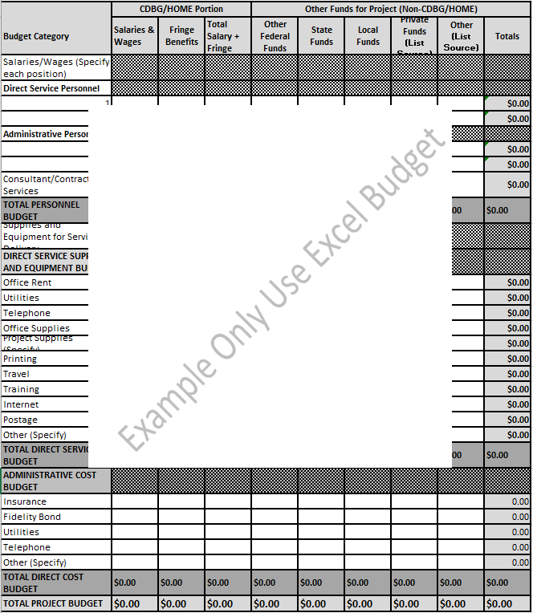
REQUIREMENTS: All applicants are requested to submit a copy of their organizations operating budget and documents requested by the city to complete the required HOME Underwriting and Subsidy Layering Review (Section 10).

