CITY OF DAVIS
2020-2021 COMMUNITY DEVELOPMENT BLOCK GRANT APPLICATION

PART ONE:

Organization Name: ___________________________________________________

Name: ___________________________ Title: ______________________ Phone: _____________________

Mailing Address: __________________________________________________________________________

Email Address: ____________________________________________________________________________

PART TWO:

Proposed Project Location: __________________________________________________________________
If the project is a capital project, an economic development activity or a target area project, include a copy of the map showing the project areas boundaries, the census tracts/block groups (ct/bg) and the low/mod percentage in each ct/bg.)

Total Proposal Request: $______________________ Minimum Request: $ _____________________

CDBG Eligible Category: __________________________________________________________________
(See List A in Application Packet)

National Objective Compliance/Low and Mod Benefit: _________________________________________
(See List B in Application Packet)
City Council Identified Critical Needs: (See List C in Application Packet)

- _______________________________________________________
- _______________________________________________________
- _______________________________________________________

Beneficiary Information:

___________ Total number of beneficiaries in proposed project
___________ Number of beneficiaries in program to be served with CDBG funds
___________ Percentage of the CDBG beneficiaries with low/moderate income
___________ Cost ($) per CDBG beneficiary (CDBG Request/CDBG Beneficiaries) CITY OF DAVIS
___________ Unit of service to determine cost per beneficiary (meal, grocery bag, kit, hour, day/night,
week, etc) (Public Services Only)

2020-2021 COMMUNITY DEVELOPMENT BLOCK GRANT APPLICATION

PART THREE: Scope of Proposal

a. Need/Target Group (Describe the need for the activity and the group being served)
b. Project Description/Benefit (Activity Summary: Describe the activities of the proposed budget and benefit)

c. Outreach (Describe the outreach your organization will provide for the CDBG-funded project, as well as provide a list of the languages currently included in your organizational outreach)

d. Organizational Capacity (Summarize your organizational capacity for the proposed project)

e. Partnerships and Other Resources (List other agencies you collaborate with and indicate whether or not your proposed project is duplicative of other projects operated by local public or non-profit organizations)

PERFORMANCE MEASUREMENTS AND SCHEDULE
ACTIVITY  (What the program does to fulfill its mission) | INDICATOR  (The direct products of program activities)  SERVICE #s | OUTCOME  (Benefits that result from the program) | COMPLETION DATE  (When the specific task is completed)

CITY OF DAVIS
COMMUNITY DEVELOPMENT BLOCK GRANT PROGRAM

BUDGET SUMMARY FOR PROPOSED PROJECT*
* Please use Project Budget Summary Excel form available on the City of Davis website and revise budget items as needed
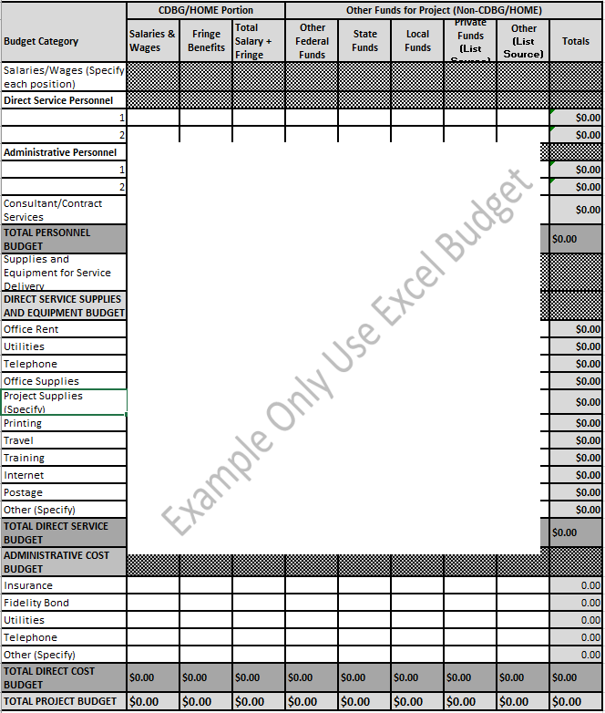

All applicants are requested to submit a copy of their organization’s Operating Budget.

CITY OF DAVIS
COMMUNITY DEVELOPMENT BLOCK GRANT PROGRAM

CAPITAL PROJECT BUDGET SUMMARY*
* Please use Capital Budget Summary Excel form available on the City of Davis website and revise budget items as needed
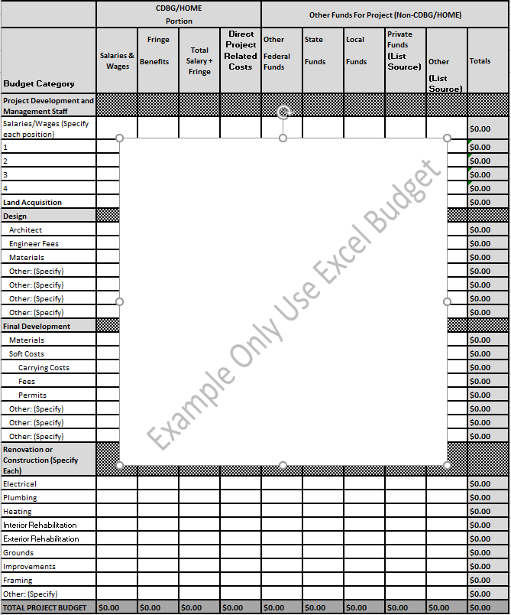
All applicants are requested to submit a copy of their organization’s Operating Budget.

