CITY OF DAVIS
2019-2020 HOME INVESTMENT PARTNERSHIPS PROGRAM APPLICATION

PART ONE:

Organization Name: ___________________________________________________

Name: ___________________________ Title: ______________________ Phone: _____________________

Mailing Address: __________________________________________________________________________

Email Address: ____________________________________________________________________________

PART TWO:

Proposed Project Location: __________________________________________________________________

Is the applicant claiming status as a Non-Profit Community Housing Development Organization (CHDO)? (Applicants will be required to provide qualifying documentation)

______ Yes _____ No

HOME Eligible Activities Category: _______________________________________
(See List A in Application Packet)

Low Income Benefit: ______________________________________
(See List B in Application Packet)

City Council Identified Critical Needs: (See List C in Application Packet)

- _______________________________________________________
- _______________________________________________________
- _______________________________________________________

Beneficiary Information:

_ Total number of beneficiaries in proposed project
_ Number of beneficiaries in proposed project to be served with HOME funds
_ Percentage of the HOME beneficiaries with low income
_ Cost ($) per HOME beneficiary (HOME Request/HOME Beneficiaries)

PART THREE: Scope of Proposal

a. Need/Target Group (Describe the need for the activity and the group being served)
b. Project Description/Benefit (Activity Summary: Describe the activities of the proposed budget and benefit)

c. Outreach (Describe the outreach your organization will provide for the HOME-funded project, as well as provide a list of the languages currently included in your organizational outreach)

d. Organizational Capacity (Summarize your organizational capacity for the proposed project)

e. Partnerships and Other Resources (List other agencies you collaborate with and indicate whether or not your proposed project is duplicative of other projects operated by local public or non-profit organizations)

PERFORMANCE MEASUREMENTS AND SCHEDULE
ACTIVITY  (What the program does to fulfill its mission) | INDICATOR  (The direct products of program activities)  SERVICE #s | OUTCOME  (Benefits that result from the program) | COMPLETION DATE  (When the specific task is completed)

BUDGET SUMMARY FOR PROPOSED PROJECT*
* Please use Project Budget Summary Excel form available on the City of Davis website and revise budget items as needed
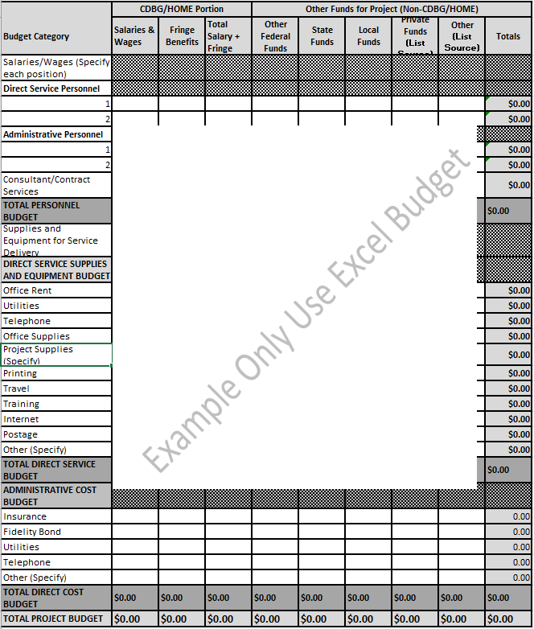
All applicants are requested to submit a copy of their organization’s Operating Budget.

CAPITAL PROJECT BUDGET SUMMARY*
* Please use Capital Budget Summary Excel form available on the City of Davis website and revise budget items as needed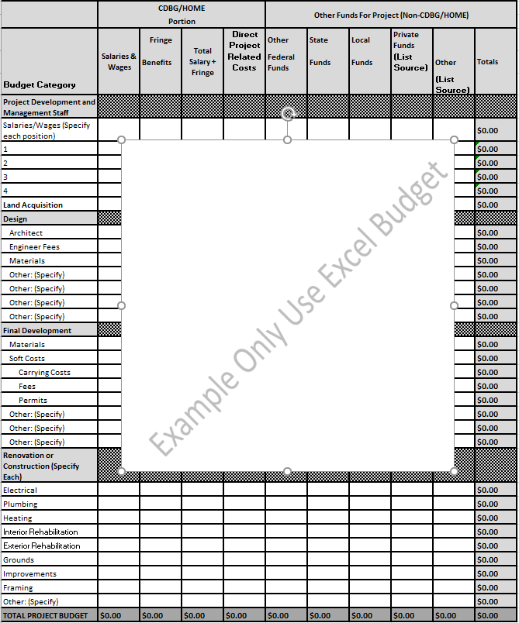
All applicants are requested to submit a copy of their organization’s Operating Budget.

HOME APPLICATION SUBMISSION REQUIREMENTS FOR UNDERWRITING AND SUBSIDY LAYERING REVIEW
– IF APPLICABLE

Per 24 CFR 92.250, the City of Davis is required to establish guidelines for subsidy layering review and underwriting reviews on all HOME-funded housing projects. The City reserves the right to be more stringent than the underwriting guidelines, dependent upon project type, construction type, and other varying factors.

To apply for HOME funding, all applicants must submit all materials required by the HOME Request for Proposals checklist. Applicants will need to submit all items prior to receiving a formal commitment of funds from the City. All items should be available with the initial application.

The City reserves the right to require additional due diligence items as needed, to evaluate the project according to federal HOME guidelines, and in order to document compliance with HOME and other applicable federal regulations. The City further reserves the right to request additional documentation in circumstances where a project is requesting other types of City affordable housing funds, a land dedication site, or other local resources or subsidies.

Below please find a list of the items required to be submitted for this review.

APPLICATION
- Complete response to the City’s HOME Request for Proposals, including all required certifications and attachments.
- Executive summary containing a brief synopsis of the proposed development and number of units, location, project cost and proposed financing. This should include a brief description of proposed complex (frontal elevation and floor plan only), proposed site plan, amenities, and accessibility/adaptability provisions.

MARKET DATA: Developers must, as part of their application, provide evidence of sufficient demand for the proposed units (all unit types, including HOME and non-HOME units and special needs units).

- Recent sale/vacancy data for neighborhood - assess sales and rentals for planned units, pricing, demand for similar units, time on the market, vacancy rates, etc.
- Evidence of demand - applications/waitlists, analysis of the pool of potential buyers/renters in eligible income range, vacancy rates and market context (project area and citywide).
Using this data, the application is required to:
- Evaluate general demographic, economic, and housing conditions in the community.
- Delineate the market area by identifying the geographic area from which the majority of a project’s tenants or buyers are likely to come. (census tracts, neighborhoods, etc.)
- Quantify the pool of eligible tenants or buyers in terms of household size, age, income, tenure, and other relevant factors.
- Analyze the competition by evaluating other housing opportunities with an emphasis on other affordable rental developments or sales opportunities in the market area.

- Asses the market for the planned units and determine if there is sufficient demand to sell the HOME-assisted housing within nine months of construction completion or to rent the HOME-assisted housing within 18 months of project completion.
- Evaluate the effective demand and the capture rate, usually expressed as a percentage (the project’s units divided by the applicant pool). The capture rate is the percentage of likely eligible and interested households living nearby who will need to rent units in the proposed project in order to fully occupy it. The lower this rate, the more likely a project will succeed.
- Estate the absorption period. Plan how many units can be successfully leased or sold each month and how long it will take to achieve initial occupancy/sale of the HOME units and stabilized occupancy for the project as a whole.

DEVELOPER CAPACITY AND FISCAL SOUNDNESS: All HOME applications must include financial statements from all underlying owners and guarantors. Developers must have a net worth equal to 10% the total development cost with net liquid assets equal to 3% of the total development cost. At its discretion, the City will consider lower net worth and net liquid assets, if adequate information is provided to the developer’s capacity and fiscal soundness. Applicant must provide the amounts and terms for any other financing being provided to the project.

- Developer Statement of Qualifications that identifies:
- Recently completed comparable projects
- All projects underway and/or pending
- Staff assigned to this project and their role and experience
- Disclosure of any identity of interest purchases/contracting relationships
- Current balance sheet
- Current year budget with comparison of actual performance YTD vs. projections
- Most recent corporate audit or reviewed financial statements
- Most recent tax returns (990s for nonprofit developers)
- Completed CHDO Staff Experience & Organizational Capacity Checklist (as applicable)

- Site and Product Information:
- Evidence of site control (e.g. option, purchase agreement, city resolution, or deed)
- Uniform Relocation Act (URA) documentation (as applicable)
- URA Notice to Seller of Voluntary Sale (as applicable)
- Seller certification regarding vacancy (as applicable)
- Rent Roll and evidence of General Information Notices to existing tenants (occupied properties only)
- Preliminary title report (as applicable)
- Statement regarding availability of utility connections
- Assessment record-or other public record documenting date of original construction for rehabilitation projects, showing applicability of Lead-based Paint and/or historic reviews (as applicable)
- Site-specific environmental record and (as applicable) estimate of remediation costs
- Radon and mold testing (as applicable)
- Lead-based Paint risk assessment (as applicable)

- Evidence of subdivision approval (as applicable)
- Plans and specifications, including site plan and elevation drawings (if available)
- Zoning/site plan and building/code review approvals (if available)
- Resident services and amenities information, including supportive services staff

- Underwriting/Financial Projections:
- Proforma showing all project costs, construction sources, and estimated sales proceeds
  - The proforma must explicitly show: An itemized breakdown of development hard and soft costs by unit including any allowances for soft costs such as architectural fees, carrying costs, etc.; the hard costs of any buildings and their uses so that the city can complete preliminary HOME cost allocation calculations. (Stand-alone accessory structures like a detached garage may be included in the project but are not HOME-eligible and must be paid for with another funding source.)
- Commitments and/or pending applications for other financing, both permanent and construction loan sources.
- Documentation of construction/rehabilitation costs (e.g., estimate by general contractor, preliminary bids, etc.)
- Estimates/documentation of professional services and soft costs (e.g. architectural fees, construction period taxes/insurance, marketing expenses, etc.)

All project costs must be reasonable and customary. The City reserves the right to review any line-item cost to ensure that total project costs are not excessive. Additionally, HOME projects will be subject to the following specific cost limitations:
i. The maximum allowable developer fee is 15% total development costs, or as otherwise permitted under TCAC regulations if the project plans to utilize tax credits.
ii. Acquisition costs are limited to fair market value as determined by a third-party appraisal.

Unless prior approval has been obtained from the City, all project hard costs and all professional fees should be the result of a competitive bidding process. The City expects developers to seek multiple bids, including outreach to women and minority-owned businesses, and identify the most advantageous bidder based on cost, track record of accomplishment, references, experience with similar type projects and other pertinent factors.

MARKETING EFFORT AND BUYER/RENTER INFORMATION
- Leasing/Sales & Marketing plan outline
- Description of primary market and outreach strategies
- Availability of homebuyer counseling services and appropriate referral plan (as appropriate)
- Availability of appropriate first mortgage products (as appropriate)
- Waiting list(s) of interested buyers/renters
- Income verification package outline

PRIOR TO USE OR ESCROW CLOSING ON HOME FUNDING
- Documentation of existing property value (e.g. tax assessment, appraisal, etc.)
- Title insurance (as applicable)
- Documentation of utility availability and connection costs

- Water/sewer, electric, gas connections map
- New projects will be required to provide an independent market study for the City

HOME PROGRAM
Background and Program Information

HOME was created by the National Affordable Housing Act of 1990 (NAHA). In addition to HOME, this Act incorporates several other major new housing initiatives including:

HOPE I Transfer of public and Indian housing to home ownership
HOPE II Transfer of subsidized, privately owned multifamily housing to home ownership
HOPE III Promotion of single family ownership for first time home buyers
Preservation Preservation of federally subsidized rental housing with expiring subsidies
Special Needs Programs for the elderly and those with special needs
Consolidated Plan Established comprehensive housing strategy requirements

HOME is a federally funded, large scale grant for housing. Funds are allocated by a formula to participating jurisdictions (PJs), the state and local government who receive funds to operate the program. As a housing program with great flexibility, state and local governments have choices with respect to:
- Type of properties to be assisted
- The types of development (new construction, modest or major rehab, etc.) to be undertaken
- The forms and amounts of financing to be offered
- The quality and type of housing provided
- The households assisted
- Procedures for running the program

The intent of HOME is:
- To expand the supply of decent, safe, sanitary and affordable housing, primarily rental housing.
- To strengthen the abilities of state and local governments to provide housing.
- To assure that federal housing services, financing and other investments are provided to state and local governments in a coordinated, supportive fashion.

HOME is designed as a partnership among the Federal governments, state and local governments and those in the for-profit and non-profit sectors who build, own, manage, finance and support low income housing initiatives. The partnership features of HOME include:
- Matching funds: PJs must add their own resources to the federal funds appropriated for HOME. PJs are required to annually contribute a 25% match for funds disbursed for affordable housing activities.
- Non-profit Partnerships: HOME not only allows, but mandates, partnerships with non-profit developers, sponsors and owners. 15% of each PJ allocation must be set-aside for non-profit.

- Federal Rules, but Local Design and Implementations: The HOME regulations provide the policy framework for HOME, but state and local jurisdictions design programs within the boundaries of national policy that meet their needs.
- Federal Money, but Local Monitoring: The federal government provides much of the money, but PJs must carefully monitor rents and occupancy to assure that the funds benefit low income households.

ALLOCATION OF FUNDS
Each PJ receives a formula allocation. Overall, 40% of funds are allocated to states and 60% to local governments.

Within the formulas allocation, PJs must set-aside a minimum of 15% of every allocation for Community Housing Development Organizations (CHDOs).

MINIMUM FORMULA ALLOCATIONS
States receive a minimum allocation of $3 million dollars.

Local Governments may participate in the HOME program if:
- Their formula allocation is $750,000 or greater; or
- Their formula allocation is less than $750,000 but more than $500,000 and
  - the state, local government or both transfer sufficient resources to the jurisdiction to achieve at least a $750,000 funding level;
  - the local government has a PHA; and
  - the local government has a demonstrated capacity to carry out the HOME program.

States may transfer their HOME monies to local governments in order to help them achieve the $750,000 threshold.

In fiscal years in which Congress appropriates less than $1.5 billion for the HOME Program, the minimum threshold is reduced to $500,000.
DESIGNATION AS A PARTICIPATING JURISDICTION AND PROGRAM DESCRIPTIONS
In order to become a PJ, government must:
- Meet the $750,000 ($500,000 in fiscal years in which Congress appropriates less than $1.5 billion) funding threshold or provide one or both of the following:
  - Authorization from the State that it will transfer state HOME funds. States not wishing to become PJs may transfer funds sufficient to allow local PJs to achieve the $750,000 threshold level.
  - Evidence (a letter from the governor or chief executive officer) that state or local funds are approved and budgeted.
- Notify HUD of their intent to become a PJ within 30 days of publication of the NOFA.
- Have a HUD approved Consolidated Plan (comprehensive housing affordability strategy.)

Program descriptions are submitted annually, general within 45 days of the publication of a NOFA, or 45 days of designation as a PJ, whichever is later.

COMMITMENT AND EXPENDITURE DEADLINES
Time frames for committing and expending HOME funds are very short. From the time HUD executes a HOME Investment Partnership Agreement with the PJ, the PJ has:
- 24 months to enter into written agreements with developers, owners, contractors, sub-recipients, state recipients and Community Housing Development Organizations to reserve funds.
- 5 years to expend funds.

Failure to meet these time frames results in loss of HOME funding.

HOME – THE FOUNDATION
Affordable housing needs identified in a State or local government Consolidated Plan are typically diverse. HOME Program Funds can be used to address many of these diverse needs – whether for property purchases, property development or property improvement and for homebuyers, existing homeowners or tenants.

OVERVIEW
The HOME Program offers communities the opportunity to address a wide array of affordable housing needs.

The HOME Program statute and regulations also contain numerous new concepts and requirements, often expressed as thresholds and percentages. This module is designed to provide “the foundation” or basic requirements of the Program. It provides a summary of the key terms, players and program activities possible in the HOME Program. These requirements will be discussed in more detail later in this training.

