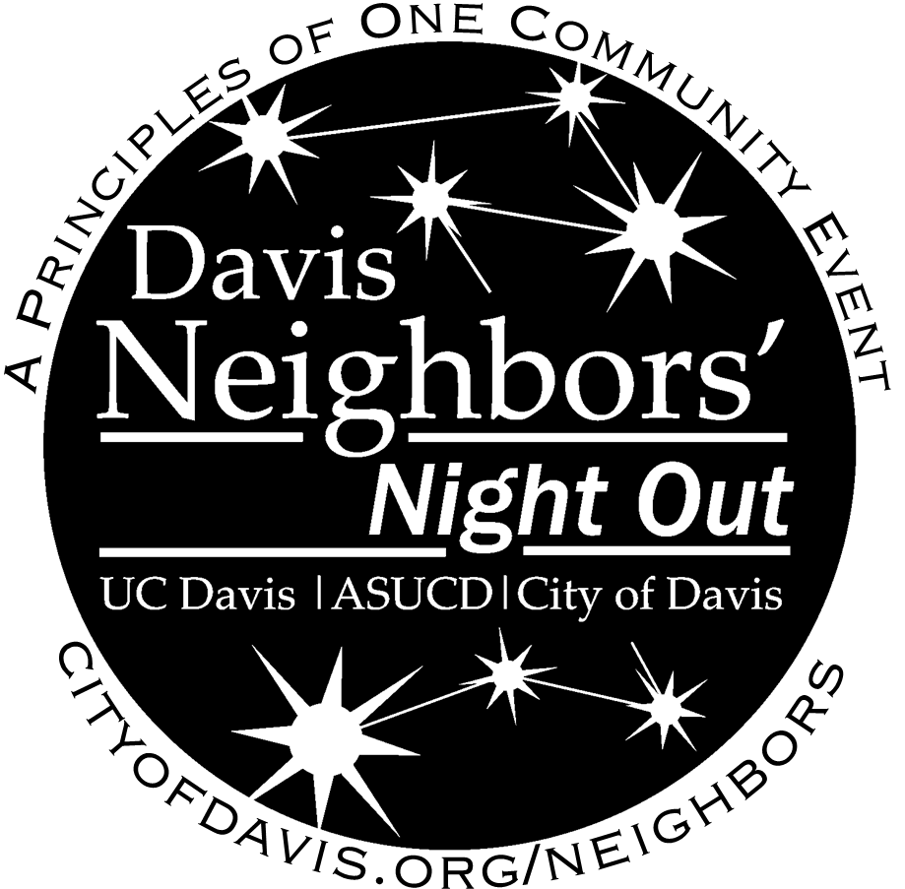

Date: Sunday, October 16, 2016 Host:

Location: Contact Info:

Time: Event Notes:

Event Type: Please RSVP To:

**Davis Neighbors’ Night Out is a celebration of our community and provides an informal opportunity for**

**neighborhoods to get to know each other. For more information contact your host or**

**City staff Carrie Dyer at 757-5602 or visit: cityofdavis.org/neighbors**

**Portions of the street may be closed or blocked for this event.**

**You’re Invited to the annual**

**Davis Neighbors Night Out event!**

**UC Davis Students Welcome!**